SIMATS ENGINEERING (SAVEETHA SCHOOL OF ENGINEERING)
Department of Computer Science and Engineering
ASSESSMENT TOOL 2 – Industry Problem Solving Task
Course Code: | CSA06 |  | Course Title: | Design and Analysis of Algorithms
CO Assessed: | CO4: Articulation (BL4, BL5) |  | Assessment: | Assessment Tool 2 – Industry Problem Solving Task
Weightage: | 20% of CIA |  | Total Marks: | 100 (2 Questions × 50 Marks)
CO4 Statement: | Solve optimization problems using dynamic programming and greedy strategies.
Student Name: | CH.Akhil |  | Reg. No.: | 192525250
Section / Batch: | 2025 |  | Date: | 29 08 26
Instructions to Students
- Answer both questions. Each question carries 50 Marks. Total: 100 Marks.
- Carefully analyze the given questions.
- Explain in detail with sample code if needed.
- Clearly identifies all key issues.
- Thorough analysis with validated results and performance evaluation
Question Type |  | Description |  |  | Questions | Total Marks
Industry Problem Solving Task |  | Focus on Solving optimization problems using dynamic programming and greedy strategies |  |  | Q1 – Q2 | 100

SECTION A – Industry Problem Solving Task

1.
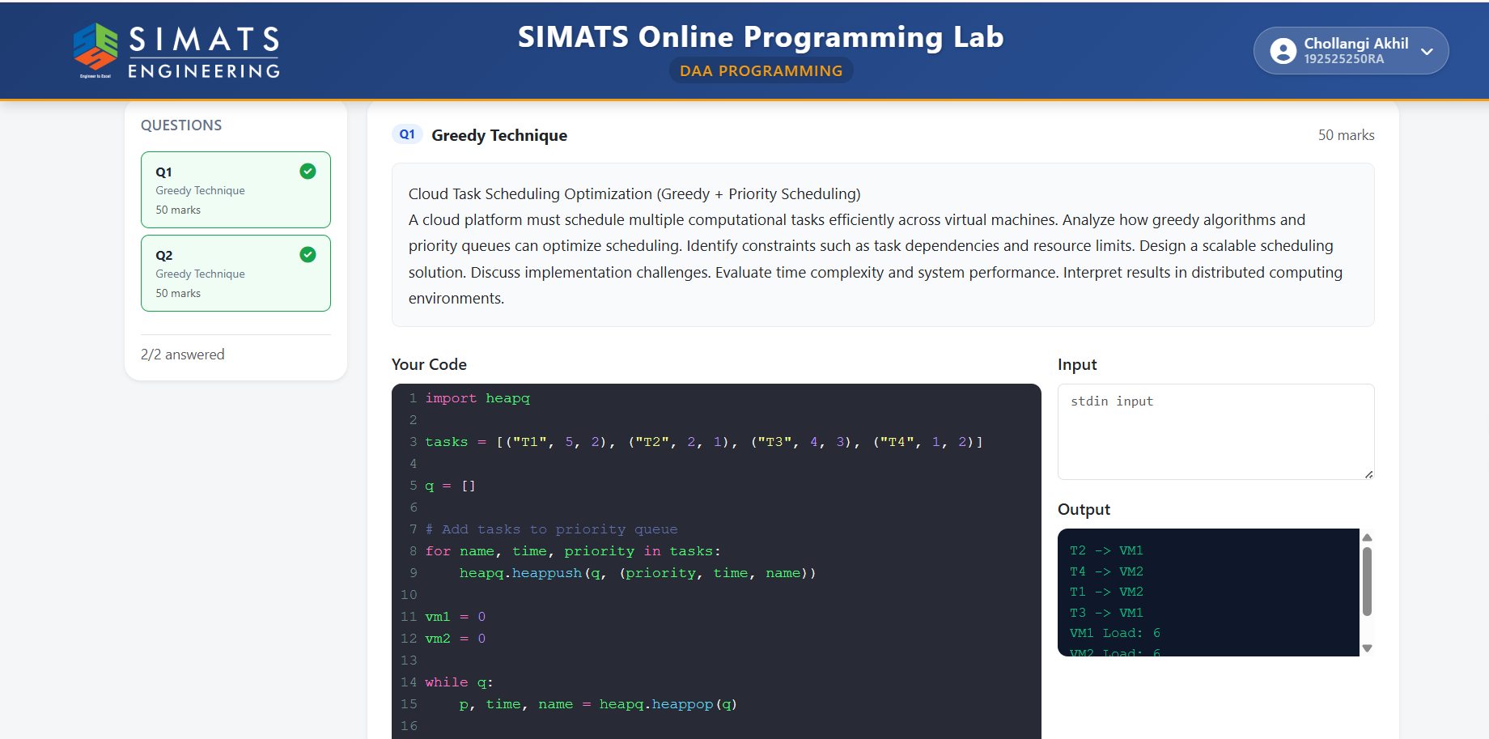

2.
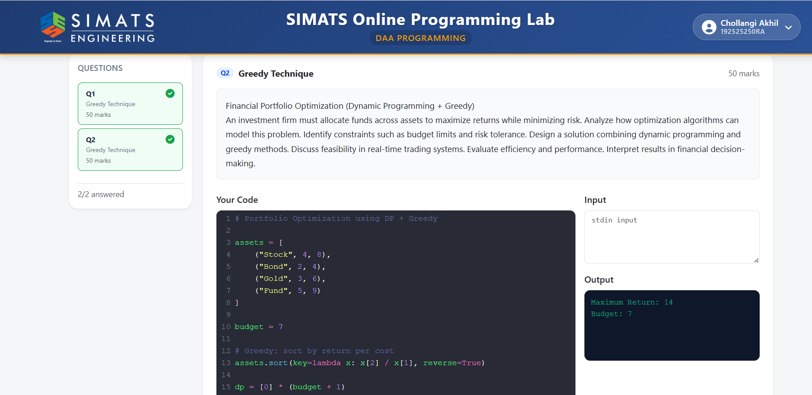

Code of Conduct
I CH.Akhil (192525250) certify that this submission is my original work and that I have adhered to the guidelines specified for this assessment. I understand that any violation of academic integrity rules will result in disciplinary action.
Signature of the Student: CH.Akhil

RUBRICS FOR CALCULATION

Case Study | Understandin g of Industry Problem  (20) |  | Application  of  Engineerin g Concepts  (25) | Solution  Design  (25) | Use of  Tool s  (15) | Analysis  (10) | Professionalis m  (5) | Total  Marks  (Each -  50)
Q1
Q2
 |  |  |  |  |  | Overall Total (100)
Faculty In-charge | Course Coordinator | Head of Department
Industry Problem Solving Task
Criteria | Weightage | Level 4 – Exemplary | Level 3 – Proficient | Level 2 –  Developing | Level 1 – Beginning
Understanding of Industry Problem | 20% | Comprehensive understanding of  real-world problem and constraints | Good understanding with minor gaps in requirements | Basic understanding; some  requirements unclear | Poor understanding; misinterprets problem context
Application of  Engineering Concepts | 25% | Applies advanced and relevant concepts  effectively to solve the problem | Applies appropriate  concepts with minor errors | Limited application of concepts | Incorrect or no application of concepts
Solution Design | 25% | Innovative, practical, and feasible solution  aligned with industry standards | Logical and feasible solution with minor gaps | Basic solution with limited  feasibility | Unclear or impractical  solution
Use of Tools | 15% | Effective use of modern tools,  technologies, and real  data | Appropriate use of tools with correct implementation | Limited or inconsistent use of tools | Minimal or incorrect use of tools
Analysis | 10% | Thorough analysis with validated results and performance evaluation | Good analysis with reasonable validation | Basic analysis with limited  validation | Poor or no analysis
Professionalism | 5% | Highly professional, well-documented,  and clearly presented  work | Good documentation and presentation | Basic documentation with some gaps | Poor documentation and presentation
Mark Evaluation:

Name: __________________  Signature: _______________ | Signature: _______________ | Signature: _______________
Date: ___________________ | Date: ___________________ | Date: ___________________

